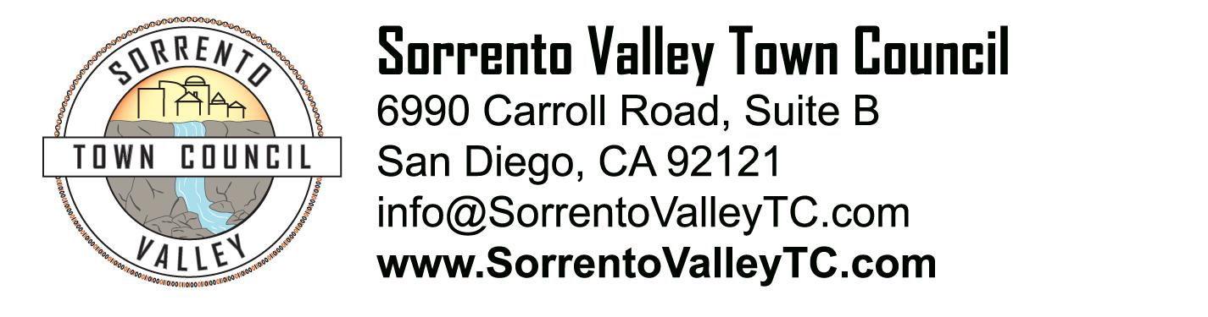

SVTC Meeting Agenda
Thursday, October 09, 2014
7:00pm
6990 Carroll Road, San Diego, CA 92121

- Call to Order: 7pm
Pledge of Allegiance
- Administrative Matters
  - Agenda deletions and/or additions
  - Approval of August meeting minutes
- Public comment
- Recognition of elected officials, their representatives, candidates for office
- Sorrento Valley Spooktacular
- SVTC business brochure
- Update on the status of the Sorrento Valley neighborhood signs
- New Business:
a. Sorrento Valley Spooktacular
- Adjournment

