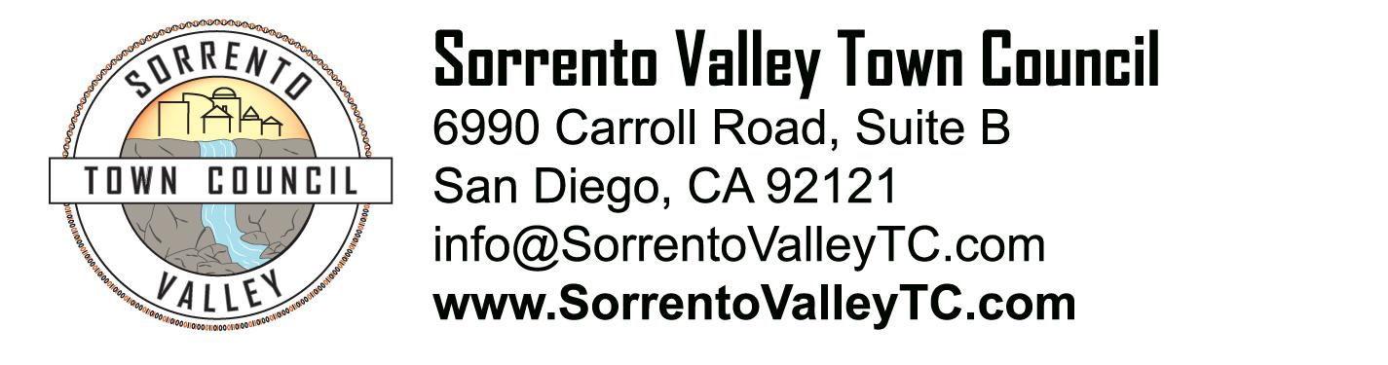

SVTC Meeting Agenda
Thursday, September 11, 2014
7:00pm
6990 Carroll Road, San Diego, CA 92121

- Call to Order: 7pm
Pledge of Allegiance
- Administrative Matters
  - Agenda deletions and/or additions
  - Approval of August meeting minutes
- Recognition of elected officials, their representatives, candidates for office
- Penasquitos Emergency Response Council presentation
- Update on the Sorrento Valley Beer Festival
- Update on the status of the Sorrento Valley neighborhood signs
- Report on the new “Welcome to Mira Mesa” monument
- New Business:
  - SVTC business brochure
  - Business email campaign
  - Endorsement of Clean Elections Campaign
- Public comment
- Adjournment

