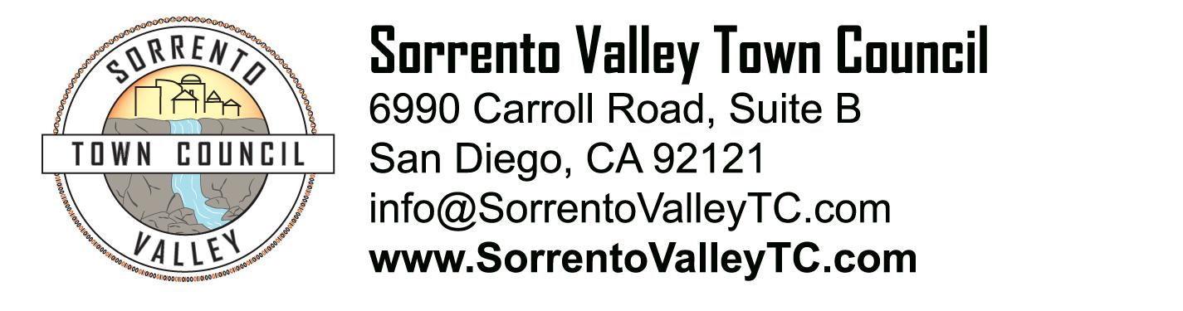

SVTC Meeting Agenda
Thursday, May 19, 2022
7:00pm
Google Meets

- Call to Order: 7:00pm
- Administrative Matters
a. Agenda deletions and/or additions
b. Approve the Agenda
c. Approval of April 21, 2022 meeting minutes

- Elected Officials/Government Agencies a. Officer John Briggs: CRO Northwestern Division
b. Denise Torres: from City Council D6 c. Michaela Valk: from Mayor Todd Gloria's
d. Jeff Yuen: County Board of Supervisors D3 Terra Lawson-Remer
e. Rachel Dugan: Congress 52nd District Scott Peters
- Committee Reports a. Sorrento Valley Railroad station update - Harsh/Sean
b. Presidents Report - Lil

- New Business
a. Colonel Bedell from MCAS Mira Mar coming to our June meeting

- Old Business
a. Neighborhood Little Library update - Susan
b. New reflective signage on SVB

IX. Adjournment.
X. Next meeting is June 16, 2022

