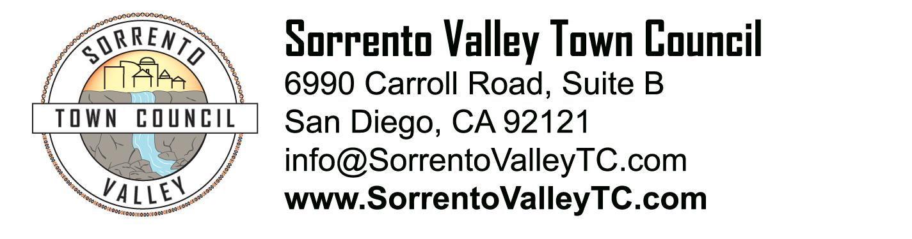

SVTC Meeting Agenda
Thursday, August 14, 2014
7:00pm
6990 Carroll Road, San Diego, CA 92121

- Call to Order: 7pm
Pledge of Allegiance
- Administrative Matters
  - Agenda deletions and/or additions
  - Approval of June meeting minutes
- Recognition of elected officials, their representatives, candidates for office
- Guest Speaker: John Hartley with Clean Elections Champagne
- Old Business:
  - President’s report on Sorrento Valley Craft Brew and Food Festival
  - Vote on venue booking
- Public comment
- Adjournment

