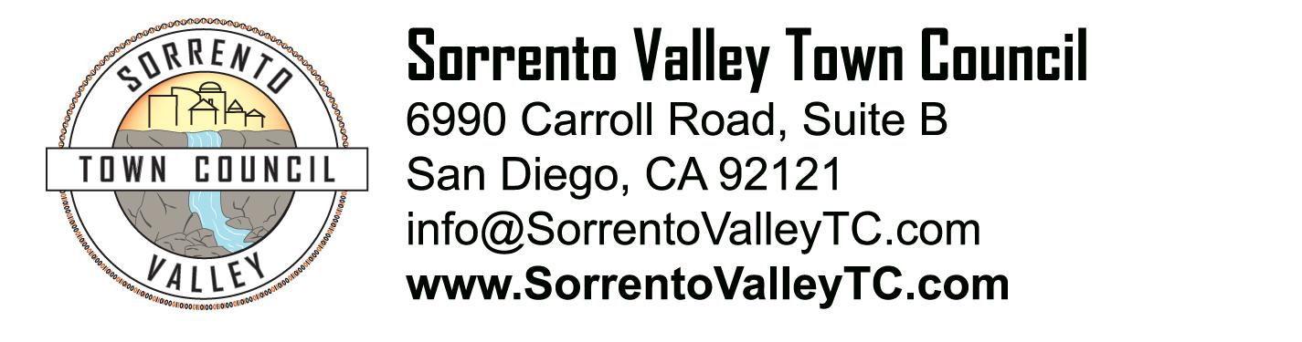

SVTC Meeting Agenda
Thursday, March 2, 2017 7:00pm

- Call to Order: 7pm
- Administrative Matters
  - Agenda deletions and/or additions
  - Approval of meeting minutes
- Public comment
- Restricted Reserve Account update
- Recognition of elected officials, their representatives, candidates for office
- Sorrento Valley Beer Fest update
- SDG&E Transmission Line Project
- SVTC Grants update
- MMCPG Elections announcement
- City DOTS program
- Adjournment

