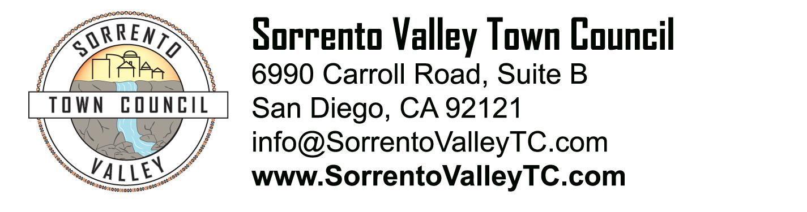

SVTC Meeting Agenda
Thursday, April 10, 2014
7:00pm
6990 Carroll Road, San Diego, CA 92121

- Call to Order: 7pm
Pledge of Allegiance
- Administrative Matters
  - Agenda deletions and/or additions
  - Approval of Last Meeting’s Minutes
- Guest speaker Donna Frye on Open Government Initiative
- Election of new board members for two open seats
- Recognition of first responders
- Recognition of elected officials and their representatives
- Old Business
  - Lil Nover’s report on School Boundaries;
  - Julia’s update on the Sorrento Valley Brew and Food Fest
- New Business
  - Discussion on more ways to promote the identity of Sorrento Valley.
- Public Comment, 3 minutes per speaker
- Adjournment

